Gates Lab
Student Vitalii Stekolshchykov (TL_KCOMP_D_Y1) t00287895
2025
Contents
AND 3
Diagram: 3
True Table: 3
Conclusion: 3
NAND 4
Diagram: 4
True Table: 4
Conclusion: 4
OR 5
Diagram: 5
True Table: 5
Conclusion: 5
NOR 6
Diagram: 6
True Table: 6
Conclusion: 6
Inverter 7
Diagram: 7
True Table: 7
Conclusion: 7
Executive OR 8
Diagram: 8
True Table: 8
Conclusion: 8
Executive NOR 9
Diagram: 9
True Table: 9
Conclusion: 9
Wire 10
Diagram: 10
True Table: 10
Conclusion: 10
Compare the results to theory. Are they the same? 12
Summary 13

AND

Diagram:
Figure AND

True Table:
S0 | S1 | Z=A.B
0 | 0 | 0
0 | 1 | 0
1 | 0 | 0
1 | 1 | 1

Conclusion:
The AND gate outputs 1 only when all of its inputs are 1. It represents logical multiplication - if any input is 0, the output becomes 0.

NAND

Diagram:
Figure NAND

True Table:
S0 | S1 | Z=$\overline{A.B}$
0 | 0 | 1
0 | 1 | 1
1 | 0 | 1
1 | 1 | 0

Conclusion:
The NAND gate outputs 0 only when all of its inputs are 1. In every other case, the output is 1. It is the inverted form of the AND gate.

OR

Diagram:
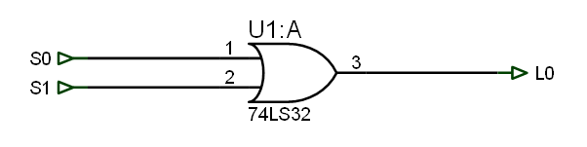
Figure OR

True Table:
S0 | S1 | Z=A+B
0 | 0 | 0
0 | 1 | 1
1 | 0 | 1
1 | 1 | 1

Conclusion:
The OR gate outputs 1 when at least one input is 1. It represents logical addition - the output is 0 only when all inputs are 0.

NOR

Diagram:
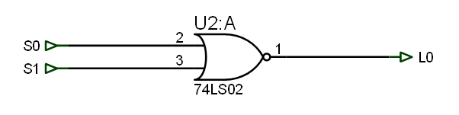
Figure NOR

True Table:
S0 | S1 | Z=$\overline{A+B}$
0 | 0 | 1
0 | 1 | 0
1 | 0 | 0
1 | 1 | 0

Conclusion:
The NOR gate outputs 1 only when all inputs are 0. It is the inverted form of the OR gate - if any input is 1, the output becomes 0.

Inverter

Diagram:
Figure Invert

True Table:
S0 | Z=$\overline{A}$
0 | 1
1 | 0

Conclusion:
The Inverter (or NOT gate) outputs the opposite logic value of its input. If the input is 1, the output is 0, and vice versa.

Executive OR

Diagram:
Figure XOR

True Table:
S0 | S1 | Z=$A⊕B$
0 | 0 | 0
0 | 1 | 1
1 | 0 | 1
1 | 1 | 0

Conclusion:
The Exclusive OR (XOR) gate outputs 1 only when the inputs are different - one is 1 and the other is 0. If both inputs are the same (both 0 or both 1), the output is 0.

Executive NOR

Diagram:
Figure XHOR

True Table:
S0 | S1 | Z=$\overline{A⊕B}$
0 | 0 | 1
0 | 1 | 0
1 | 0 | 0
1 | 1 | 1

Conclusion:
The Exclusive NOR (XNOR) gate outputs 1 when both inputs are the same - either both 0 or both 1.It is the inverse of the XOR gate.

Wire

Diagram:
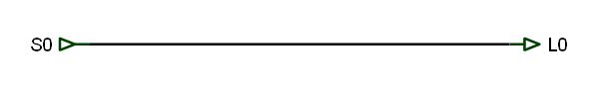
Figure Wire

True Table:
S0 | Z=$\overline{A}$
0 | 0
1 | 1

Conclusion:
A Wire simply connects one point in a circuit to another without changing the signal. It transmits the same logic value from input to output - if the input is 1, the output is 1; if the input is 0, the output is 0.

Circuit Design Exercise:

Explain how you would design and build an XNOR circuit using a combination of other gates if the ‘266 circuit was not available.
Show the circuit design and the truth table result.

Diagram:

Figure XNOR alternative

True Table:
S0 | S1 | Z=$(\overline{A⊕B)}$
0 | 0 | 1
0 | 1 | 0
1 | 0 | 0
1 | 1 | 1

Compare the results to theory. Are they the same?
The measured results from the logic box were compared to the theoretical truth tables. All results matched the expected values, confirming the correct operation of each gate.

Summary
All gates behaved according to their theoretical truth tables. The logic box successfully demonstrated how each logic gate produces a HIGH or LOW output based on different input combinations.

